Layers Report

Project 2

Smart Home

Group 1

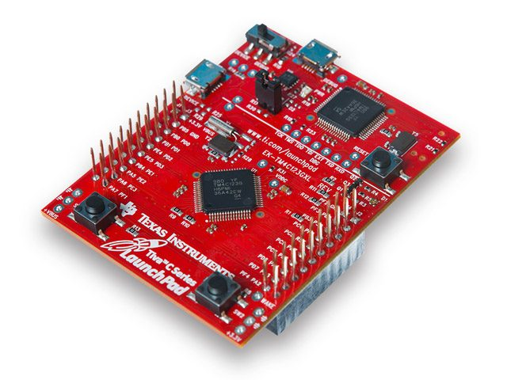

Layers Structure

**MCAL Drivers**

ADC Driver

Function Definitions

|  |  |  |
| --- | --- | --- |
| Name | ADC_readChannel | |
| Input | uint8 | channel_num |
| Return | uint16 | |
| Description |  | |

DIO Driver

Type Definitions

|  |  |
| --- | --- |
| Name | Dio_LevelType |
| Type | Enum |
| Values | STD_LOW |
| STD_HIGH |

|  |  |
| --- | --- |
| Name | Dio_PinDirectionType |
| Type | Enum |
| Values | PORT_PIN_IN |
| PORT_PIN_OUT |

|  |  |
| --- | --- |
| Name | Dio_PortName |
| Type | Enum |
| Values | GPIOA |
| GPIOB |
| GPIOC |
| GPIOD |
| GPIOE |
| GPIOF |

Function Definitions

|  |  |  |
| --- | --- | --- |
| Name | DIO_Init | |
| Input | Dio_PortName | port_name |
| uint8 | pins_mask |
| Return | void | |
| Description |  | |

|  |  |  |
| --- | --- | --- |
| Name | DIO_SetPinDirection | |
| Input | Dio_PortName | port_name |
| uint8 | pins_mask |
| Dio_PinDirectionType | pins_direction |
| Return | void | |
| Description |  | |

|  |  |  |
| --- | --- | --- |
| Name | DIO_SetPinPullUp | |
| Input | Dio_PortName | port_name |
| uint8 | pins_mask |
| Return | void | |
| Description |  | |

|  |  |  |
| --- | --- | --- |
| Name | DIO_SetPinPullDown | |
| Input | Dio_PortName | port_name |
| uint8 | pins_mask |
| Return | void | |
| Description |  | |

|  |  |  |
| --- | --- | --- |
| Name | DIO_ReadPort | |
| Input | Dio_PortName | port_name |
| uint8 | pins_mask |
| Return | uint8 | pins_level |
| Description |  | |

|  |  |  |
| --- | --- | --- |
| Name | DIO_WritePort | |
| Input | Dio_PortName | port_name |
| uint8 | pins_mask |
| Dio_LevelType | pins_level |
| Return | void | |
| Description |  | |

|  |  |  |
| --- | --- | --- |
| Name | DIO_FlipPort | |
| Input | Dio_PortName | port_name |
| uint8 | pins_mask |
| Return | void | |
| Description |  | |

PWM Driver

Type Definitions

|  |  |
| --- | --- |
| Name | PWMChannel |
| Type | Enum |
| Values | PWM0 |
| PWM1 |
| PWM2 |
| PWM3 |
| PWM4 |
| PWM5 |
| PWM6 |
| PWM7 |

|  |  |
| --- | --- |
| Name | PWMModule |
| Type | Enum |
| Values | PWMModule0 |
| PWMModule1 |

Function Definitions

|  |  |  |
| --- | --- | --- |
| Name | PWM_Init | |
| Input | PWMModule | module |
| PWMChannel | channel |
| uint16 | period |
| uint16 | duty |
| Return | void | |
| Description |  | |

|  |  |  |
| --- | --- | --- |
| Name | PWM_SetDuty | |
| Input | PWMModule | module |
| PWMChannel | channel |
| uint16 | duty |
| Return | void | |
| Description |  | |

UART Driver

Type Definitions

|  |  |
| --- | --- |
| Name | UARTNUM |
| Type | Enum |
| Values | uart0 |
| uart1 |
| uart2 |
| uart3 |
| uart4 |
| uart5 |
| uart6 |
| uart7 |

|  |  |
| --- | --- |
| Name | PARITY |
| Type | Enum |
| Values | OFF |
| ON |

|  |  |
| --- | --- |
| Name | INTERRUPT |
| Type | Enum |
| Values | OFF |
| ON |

Function Definitions

|  |  |  |
| --- | --- | --- |
| Name | UART_Init | |
| Input | UARTNUM | UartNum |
| uint32 | BaudRate |
| PARITY | Parity |
| INTERRUPT | interrupt |
| Return | void | |
| Description |  | |

|  |  |  |
| --- | --- | --- |
| Name | UART_Available | |
| Input | UARTNUM | UartNum |
| Return | uint8 | Available |
| Description | Checks whether the targeted UART selected by UartNum is Available to read from (Receiver FIFO is empty or not).  Return 1 if available 0 if not available | |

|  |  |  |
| --- | --- | --- |
| Name | UART_Read | |
| Input | UARTNUM | UartNum |
| Return | uint8 | data |
| Description |  | |

|  |  |  |
| --- | --- | --- |
| Name | UART_Write | |
| Input | UARTNUM | UartNum |
| uint8 | data |
| Return | void | |
| Description |  | |

|  |  |  |
| --- | --- | --- |
| Name | UART_Print | |
| Input | UARTNUM | UartNum |
| uint8 | data |
| Return | void | |
| Description |  | |